Setup & Code Documentation

1. Introduction
This project is an Interactive Health Intervention Simulator built with Python and Streamlit. It projects future health outcomes (e.g., Dementia, Diabetes, Hypertension) for the US population from 2026 to 2050 based on demographic data and regression models.
The goal is to visualize how reducing specific risk factors (interventions) affects disease prevalence compared to a "status quo" baseline.

2. Environment Setup
Before running the project, you need to set up your development environment.
2.1. Install Development Tools
- Download & Install VS Code (Visual Studio Code):
  - Go to https://code.visualstudio.com/ and download the version for your OS (Windows/Mac).
  - Run the installer and follow the default prompts.
- Install Python:
  - Download Python (version 3.9 or higher is recommended) from https://www.python.org/downloads/.
  - CRITICAL STEP: During installation, check the box "Add Python to PATH".
2.2. Configure VS Code
- Open VS Code.
- Go to the Extensions view (click the square icon on the left sidebar or press Ctrl+Shift+X).
- Search for and install the "Python" extension by Microsoft.

3. Installation & Setup
- Get the Code:
  - Download this project folder to your local machine (e.g., C:\Work\RA\emulator).
- Open in VS Code:
  - Open VS Code -> File -> Open Folder -> Select C:\Work\RA\emulator.
- Create a Virtual Environment (Recommended):
  - Open the Terminal in VS Code (Ctrl + ~).
  - Run: python -m venv venv
  - Activate it:
    - Windows: .\venv\Scripts\activate
    - Mac/Linux: source venv/bin/activate
- Install Dependencies:
  - This project requires streamlit, pandas, plotly, and numpy.
  - Run: pip install streamlit pandas plotly numpy

4. Project Structure
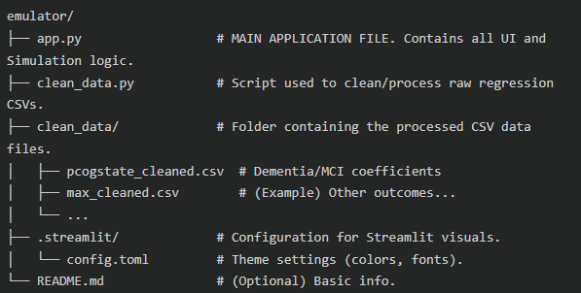
5. How to Run the App

- Ensure your terminal is open in the project folder and your virtual environment is active.
- Run the command:
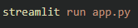
- A browser window will automatically open (usually at http://localhost:8501) displaying the dashboard.

6. Implementation Details (Logic Walkthrough)
6.1. The Data Source
The simulation relies on pre-calculated regression coefficients stored in clean_data/.
- Each row in these CSVs represents a "year" (e.g., 2.year_inc, 4.year_inc).
- Columns represent coefficients for different demographic groups (e.g., n_endpop_5564 for population count age 55-64, p_diabe_f for diabetes probability in females).
6.2. The Simulation Loop (app.py)
The core logic inside app.py follows these steps:
- User Inputs: The user selects a Target Population (e.g., Female) and an Outcome (e.g., Dementia).
- Loading Data: The app reads the specific CSV relevant to the selected outcome.
- Baseline Projection:
  - For every year (2026-2050), it looks up the baseline value from the CSV column corresponding to the selected subgroup (e.g., p_cogstate1_f).
- Intervention Projection:
  - The user sets intervention levels (e.g., "Reduce Diabetes by 30%" -> Level 0.70).
  - The model calculates the new value using the regression formula:
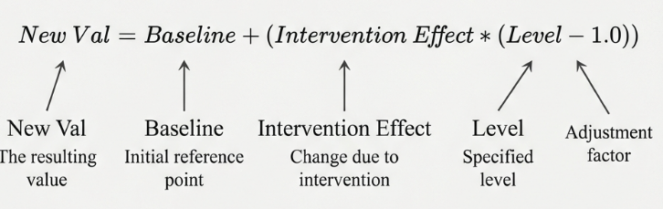
(Simplified representation: The code actually calculates the difference based on specific interaction terms found in the CSVs).
- Scaling:
  - Raw Data: Kept as original probabilities (e.g., 0.15).
  - Plots: Multiplied by 100 on-the-fly to show percentages (e.g., 15.0%).
6.3. Key Features Added
- Custom Styling: We use HTML/CSS injection for the sidebar and table styling because standard Streamlit elements are limited.
- Table Formatting: A custom formatter handles "Negative Zero" (-0.00) by forcing it to display as 0.00.
- USC Branding: Plots use specific colors (#990000, #FFCC00) to match USC brand guidelines.

7. How to Extend
- Adding a New Outcome:
  - Ensure you have a corresponding _cleaned.csv file in clean_data/.
  - Add the mapping to OUTCOME_OPTIONS dictionary in app.py.
- Adding a New Intervention:
  - Add the slider definition in the sidebar section.
  - Ensure existing regression files have coefficients for this new intervention, or update the logic to handle it.

